Changes from Revision 1
Procedure Re-braded
TÜV UK Conformity Marks updated.
The National Accreditation Logo and Symbols: Conditions for use by UKAS and UKAS accredited organisations issue date updated.

- Introduction

The following information is based on The National Accreditation Logo and Symbols: Conditions for use by UKAS and UKAS accredited organisations issued February 2024 and covers the TÜV UK Product Certification Logos when used in isolation or in combination with the National Accreditation Symbol.

Requirements

The following requirements are from Appendix B the National Accreditation Logo and Symbols: Conditions for use by UKAS and UKAS accredited organisations issued February 2024

Requirements and National Accreditation Symbols for Certification Bodies and their certified Clients

2.1 The appropriate national accreditation symbol may only be used by the client of a certification body in connection with the certification body’s award of UKAS accredited certification. The national accreditation symbol must be relevant to the certificate.

2.2 Holders of certificates issued by UKAS accredited certification bodies may use the appropriate national accreditation symbol in accordance with the requirements of this publication on stationery and publicity material or other items relevant to their certificate. The national accreditation symbol(s) shall always be used in conjunction with the logo/mark of the certification body and/or product certification scheme. Holders of accredited certificates may use the logo/mark of the certification body or certification scheme without the accreditation symbol.

2.3 Certification bodies shall ensure that they audit the use of national accreditation symbols by their certificate holders.

  - The Product Certification national accreditation symbol may only be used in connection with a product, process or service certified under an accredited product certification scheme.

  - If, in the specific case of a product certified under an accredited product conformity scheme, physical constraints prevent reproduction of the product certification national accreditation symbol to the limits specified in this Appendix, a label may be attached to the product. If that is impracticable, the label may be affixed to the primary packaging (e.g. blister pack) but not to the secondary packaging (e.g. outer, transit pack).

- Additional guidance and information on the form and display of the national accreditation symbol

  - The national accreditation symbols shall normally have a minimum height (excluding the accreditation number) of 20mm. Any enlargement or reduction shall retain the same proportions as those of the masters reproduced in this publication. The national accreditation symbol and the accreditation number shall be considered as a single entity for purposes of enlargement or reduction.

  - In exceptional circumstances, which are usually dictated by reason of space limitation or cost, the national accreditation symbols may be reproduced at a reduced height, but paragraph 3.8(c) must be satisfied.

  - Irrespective of the height of reproduction, the national accreditation symbols must, in the opinion of UKAS, be legible, with no infilling.

  - When the national accreditation logo or national accreditation symbol is printed on an unfolded portion of stationery sized no greater than A4, it shall be displayed in a size no larger than 30mm high. On larger portions of unfolded stationery, the size may be proportionately increased.

- Specific Restrictions & Requirements – Use of TÜV UK Product Certification Logo and the National Accreditation Symbol
SAMPLE
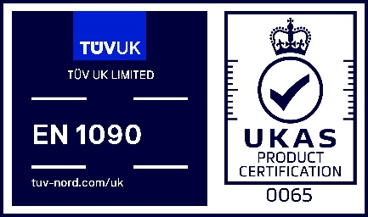  SAMPLE | 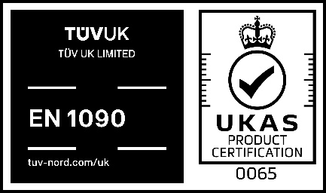  SAMPLE | 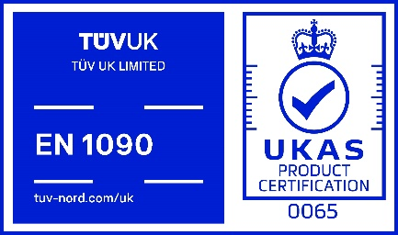
BS EN 1090-1 | BS EN 1090-1 | BS EN 1090-1
“Certificate Number” | “Certificate Number” | “Certificate Number”

4.1 The example shown is for BS EN 1090-1 the logo will be provided for the actual product certification standard, the text between the TÜV UK Product Certification Logo and the National Accreditation Symbol and the certificate number should reflect the actual product certification standard.
  - In addition to the general requirements and restrictions above the TÜV UK Product Certification Logo and the National Accreditation Symbol shown above shall:
    - not be displayed by UKAS accredited organisation or their clients, on any vehicle;
    - not be displayed on buildings and flags;
    - be displayed as shown above without alteration

- Specific Restrictions & Requirements – Use of TÜV UK Product Certification Logo

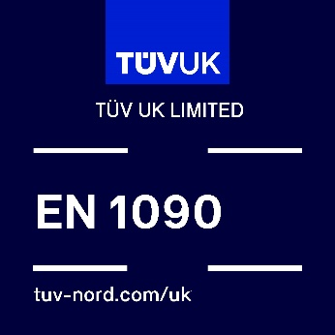  SAMPLE  SAMPLE  SAMPLE | 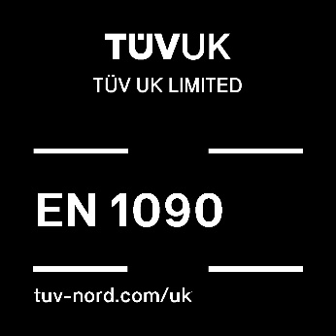 | 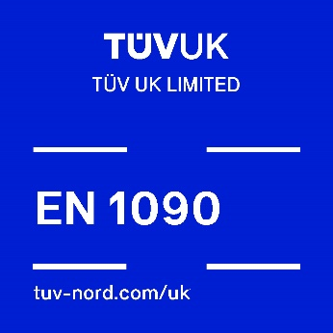
BS EN 1090-1 | BS EN 1090-1 | BS EN 1090-1
“Certificate Number” | “Certificate Number” | “Certificate Number”

5.1 The example shown is for BS EN 1090-1 the logo will be provided for the actual product certification standard, the text between the TÜV UK Product Certification Logo and the certificate number should reflect the actual product certification standard.
  - In addition to the general requirements and restrictions above the TÜV UK Product Certification:
    - may be displayed by UKAS accredited organisation's clients, on any vehicle;
    - may be displayed on buildings and flags;
    - shall be displayed as shown above without alteration.

